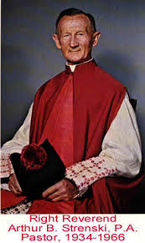
The Monsignor Strenski Award
Established on the 150th Anniversary of St. Joseph’s Polish, the Monsignor Strenski Award recognizes that individual or group who reaches out in service to those in need, as did Msgr. Strenski so faithfully well beyond his 34 years of ministry as pastor.
This award will be given on Sunday, October 21 at the 10 AM Mass. You are invited to nominate a person or group that emulates the passion and compassion of Msgr. Strenski. Simply print and complete this form and send it to the Cathedral of the Immaculate Conception Parish by September 30th. A committee of five will look at all nominations and choose the recipient.

Name: _________________________________
Reason for Nomination (please speak of the candidate’s qualities and/or service to the St. Joseph Polish Apostolate or surrounding community)

_____________________________________________________________________________________
_____________________________________________________________________________________
_____________________________________________________________________________________
_____________________________________________________________________________________
_____________________________________________________________________________________
_____________________________________________________________________________________
_____________________________________________________________________________________
_____________________________________________________________________________________
_____________________________________________________________________________________
_____________________________________________________________________________________
_____________________________________________________________________________________
_____________________________________________________________________________________
_____________________________________________________________________________________
_____________________________________________________________________________________
_____________________________________________________________________________________
Person Nominating: _____________________________________________
Phone Number: (in case committee needs more information or clarity) __________________________
Thank you for your participation! Please return by September 30!

